
Submitted by : Spogmai Jan
Roll no : 2430 -0081
Submitted to : sir nouman asim

Computer networks lab 10

TASK 01:
Create a network using a single switch and at least four PCs. Connect all the PCs to
the switch. Configure the network (Switch) to enable Telnet access. From PC0,
verify connectivity to the switch using ping and Telnet command. Change the
switch’s hostname to “S5” and configure the switch to block access to the port
connected to PC2 from PC0.
Block PC 1 Fa0/1:
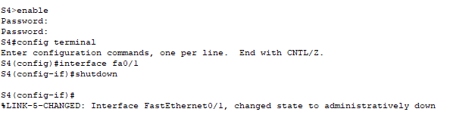

Un-Block through PC:
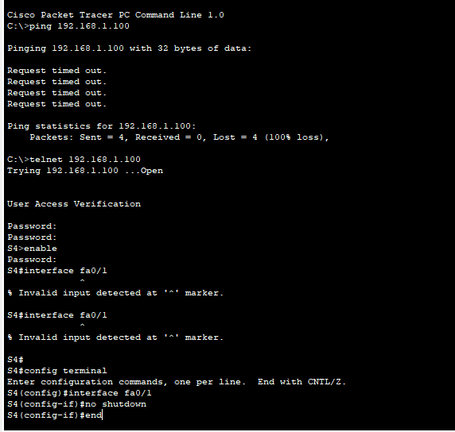
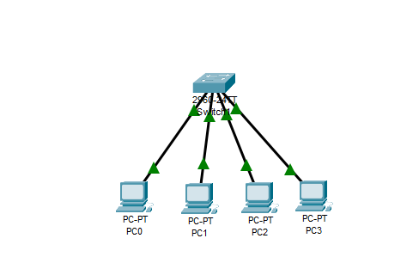

TASK 02:
Design a network in which you have one Routers with 1 switch. Switch is connected
at least 5PC’s given in the below table. Configure the router to enable Telnet access.
From PC1 and PC2, get the connectivity to the switch using ping and Telnet
command. Change the router hostname to “R6
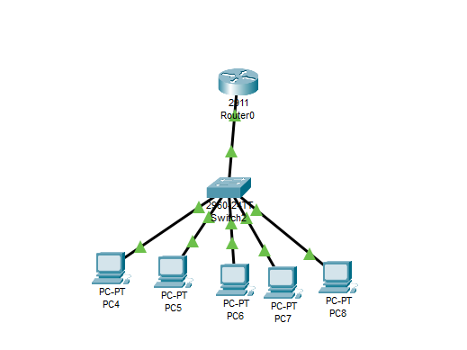
TASK 03:
Design a network using 1 routers and 2 switches, Router have Switch 1 and Switch
2 w.r.t. LAN A and LAN B with at least 3 PC’s in below table. Configure the router
to enable Telnet access. From PC0 and PC1 of LAN A, get the connectivity to the
router using ping and Telnet command. Change the router hostname to “R2” and
block the port of LAN B.
From PC3 and PC4 of LAN B, get the connectivity to the router using ping and
Telnet command. Change the router hostname to “R7”
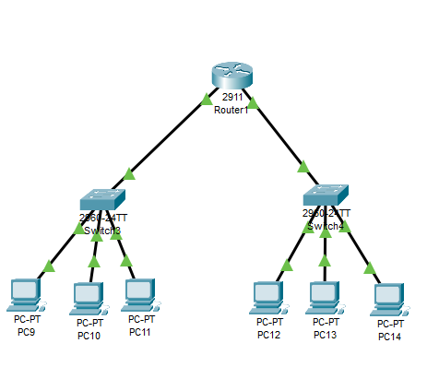
TASK 04:
Design a network using 1 routers and 3 switches, Router have Switch 1 and Switch
2 and Switch 3 w.r.t. LAN A and LAN B and LAN C with at least 2 PC’s in below
table. Configure the router to enable Telnet access. Change the name of router “R4”
from any PC.

Un-blocking G0/0 through PC:




